

**Image reconstruction from different cross**

**Section of same image**

**PRESENTED BY:**

Shivank Goel

Registration no: 201500253

**Group Id: 9**

**Under the supervision of:**

Bijoyeta Roy

(Assistant professor-1)

Computer Science and Engineering

Department of computer science engineering

**Abstract**

Image reconstruction model can help doctors in better visualization of human organs and make it easier and more accurate to diagnosis and prescribe therapy for the patient. ​ Biological imaging produces 2 dimensional images that represents different cross sections of the appropriate part of the human body. image reconstruction model is an important technique for accurate localization and evaluating brain tumor, thus helping neurosurgery planning for brain tumors. ​Accurate image reconstruction of human tissue is a challenge problem in medical imaging. In this paper, a novel image reconstruction method of human brain MRI images is proposed based on the segmentation of human tissue. First, we propose a novel region-based growing algorithm to get points of an MRI image. Then, the moving cubes algorithm is used to reconstruct the accurate 3D object model​. Results showed that the quality of the image brain tissue reconstruction was acceptable and linear interpolation of the image model improved the visualization of the brain surface morphology. This bias ﬁeld inconsistency can induce artifacts in the ﬁnal image reconstruction that can impact both clinical interpretation of key tissue boundaries and the automated analysis of the data.

**Contents**

|  |  |  |
| --- | --- | --- |
| SL. N0. | Topic | Page N0. |
| 1 | Introduction | 1 |
| 2 | Literature Survey | 2 |
| 3 | Problem definition | 4 |
| 4 | Solution Strategy | 5 |
| 5 | Flow Chart | 6 |
| 6 | Segmentation process | 7 |
| 7 | Filtering process | 11 |
| 8 | Implementation details | 12 |
| 9 | Basic steps to filter image | 15 |
| 10 | Gantt Chart | 18 |
| 11 | References | 19 |

**Introduction**

In recent years, magnetic resonance imaging has been widely used for various medical purposes. However, the traditional biological images only provide two-dimensional (2D) images and cannot been used to create an explicit three-dimensional (image) model. Therefore, reconstructing image model from 2D MRI images becomes an active research topic. The key challenge is how to obtain image data with high accuracy from original MRI images. The traditional methods of improving the image point accuracy are by improving the accuracy of region-based growing. Lavoue et al. improved the traditional seed selection scheme by dividing the pixels of the image into 9 types according to plus-minus of mean curvature and the Gaussian curvature. However, there are three main limitations of this algorithm: (1) the proposed method ignores the vertex points on the sharp edge, (2) the edge that dihedral angle is greater than the given threshold, (3) using the sharp edge information to improve the growing conditions doesn't work well on all cases. Zhang et al. used Gauss curvature to assign all vertex and set the vertex which has the larger minus Gauss curvature as the board by the threshold and minimum criteria. Their approach chooses work on MRI images since MRI images always lack feature points and are gray scale images without much color changes. ultrafast multislice imagings equences, such as single shot fast spin echo (SSFSE) or half-Fourier acquisition single shot turbo spin echo (HASTE) are increasingly popular in clinical imaging of moving anatomy, allowing the clinician to view 2D slices of anatomy in challenging clinical applications such as in utero fetal brain studies. Here we describe a framework to estimate and correct the bias ﬁeld inconsistency in each slice collectively across all motion corrupted image slices. It is necessary to develop an automatic guided software for performing cosmetic surgery by the process of simulating three-dimensional visualization techniques suitable for the display of complex structures of the facial skeleton and of skull base. Three-dimensional surface reconstruction of cranial anatomy is obtained from CT (Computer Tomographic) or MRI (Magnetic Resonance Images) images.

**Literature Survey**

|  |  |  |  |
| --- | --- | --- | --- |
| **Sl. N0.** | **Author and paper details** | **Findings** | **Relevance** |
| 1 | **Author:**T. Senthil Kumar,  Rakesh, P.B  **Paper details:**   * **Name:"**3D Reconstruction OF Facial Structures From 2D Images for Cosmetic Surgery" * 978-1-4577-0590-8/11/$26.00 ©2011 IEEE | General principle of 3d reconstruction and approach  Visualization based on region of interest | Principal and method for 3d reconstruction approach  Visualization based on region of interest |
| 2 | **Author:**Baijiang Fan, Yunbo Rao, Wei Liu  **Paper details:**   * **Name: "**Region-Based Growing Algorithm for 3D Reconstruction from MRI Images"   978-1-5090-6238-6/17/$31.00 ©20 17 IEEE | Novel 3-dimensional method of human brain mri (magnetic resonance imaging) is proposed based on the segmentation of human tissues | Segmentation methods |

|  |  |  |  |
| --- | --- | --- | --- |
| **Sl. N0.** | **Author and paper details** | **Findings** | **Relevance** |
| 3 | **Author:** Chao Yang†and Xinchun  **Paper details:**   * **Name:"**Reconstruction of Brain Tissue Surface Based on Three-Dimensional T1-Weighted MRI Images" * 978-1-4673-9098-9/15/$31.00 ©2015 IEEE | In this paper a technique was given on 3-dimensional M.R.I and 3-dimensional printing to generate a 3-dimensional model that might help neurosurgery planning. | Brain tissue segmentation and reconstruction method |
| 4 | **Author:**A. Roche, G. Subsol, X. Pennec, N. Ayache  **Paper details:**   * **Name:** "Reconstructing a 3D structure from serial histological sections" * 0262-8856/01/$ - see front matter q 2001 Elsevier Science B.V. | Problem for aligning historical section for 3-dimensional reconstruction and analysis.  Block matching strategy for alignment of historical section for 3dimensional reconstruction. | Methods to deal with alignment problem. |

**Problem definition**

* Traditional biological imaging only provides 2 dimensional images and cannot be used to create an explicit three-dimensional model.
* 2 dimensional images are not suitable for localization and evaluating brain tumor, in order to help neurosurgery planning for brain tumors.
* 2 dimensional images are not appropriate to help doctors in better visualization of human organs and make it easier and more accurate to diagnosis and prescribe therapy for the patient.
* **To develop a model that would give better three-dimensional view of biological specimen.**

**Solution Strategy**

Medical image has its own uniqueness such as human tissues’ wiggle and disturbance of power level in imaging equipment. And these unavoidable factors add some noise into image data. Adding a filter module before reconstruction module to reduce the noise can improve the precision of the image images. Filtering technique should be selected and executed after modelling the noise in the image. A proposed method proposes a image Reconstruction method of developing a image model from complete 2D CT/MRI scan of axial slides of a patient. reconstruction is the process by which extraction of surfaces is done from a image array having same density in image volume. A basic image model of outer face is created using algorithm of iso-surface reconstruction by defining proper iso-value or intensity value

**2.** Preprocessing based on filtering or segmentation

1.Datasets of biological imaging

**3.** image reconstruction based on suitable algorithm

**4.**  volumetric image generated

Fig:1

**FLOW CHART**

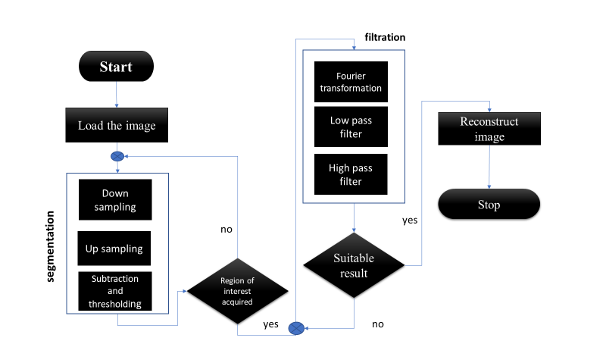

Fig:2

**Segmentation**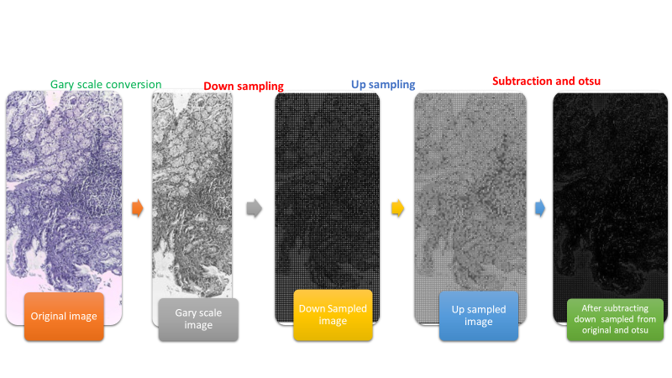

Fig:3

**Filtering** 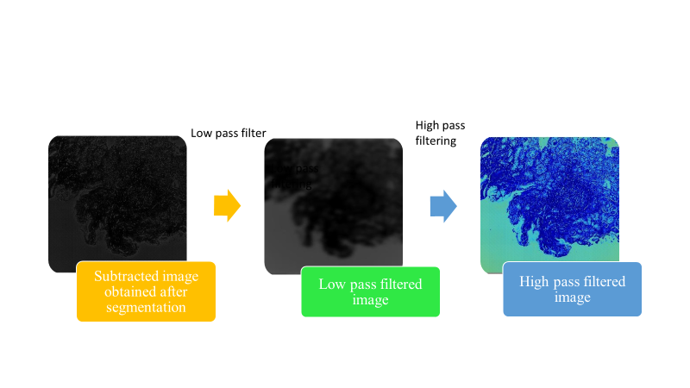 Fig:4

**Implementation details**

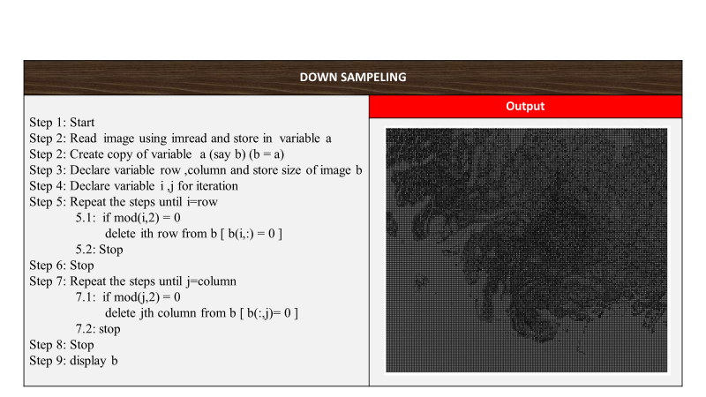fig:5

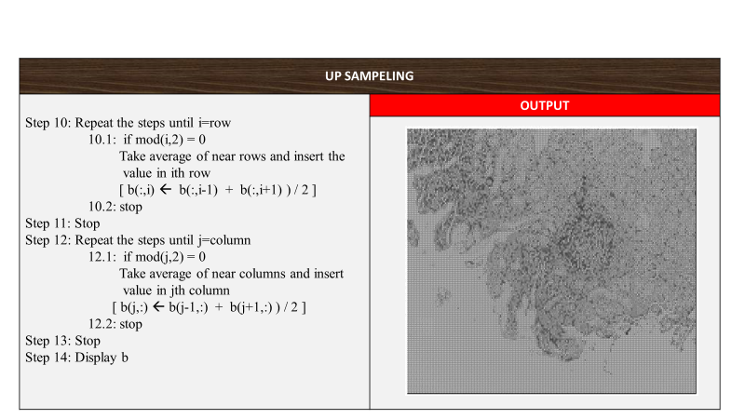

Fig:6

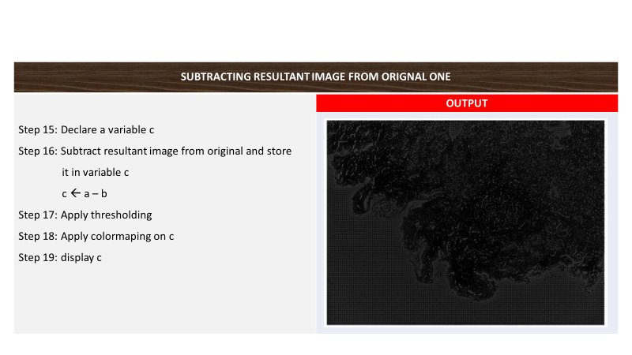

Fig:7

**Filtration process**

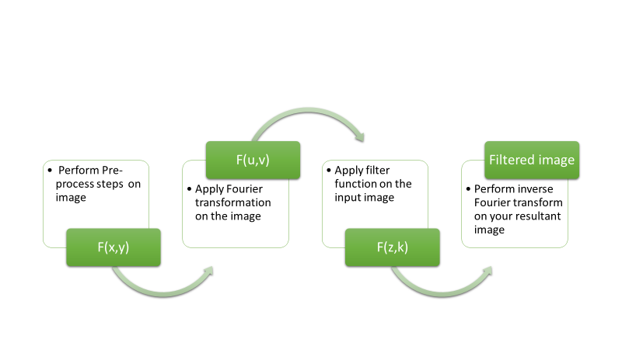

Fig:8

**Implementation details**

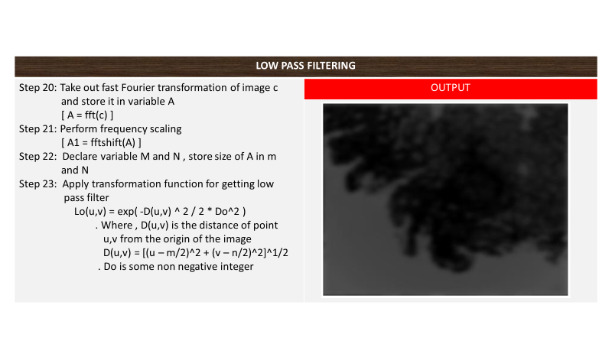fig:9

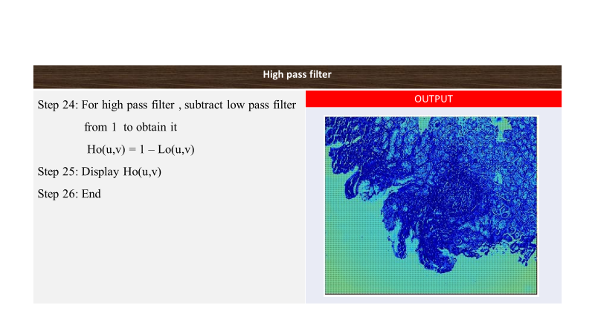

Fig:10

**Gantt Chart**

|  |  |  |  |  |  |  |
| --- | --- | --- | --- | --- | --- | --- |
| Activity | Time frame | | | | | |
| 29|01|19 15|02|19 17|03|19 30|03|19 20|04|19 | | | | | | |
| Feasibility Study |  | |  |  |  |  |
|  |  |
| Literature Survey |  | |  |  |  |  |
|  |  |
| Algorithm design |  | |  |  |  |  |
| Implementation |  | |  |  |  |  |
| testing and debugging |  | |  |  |  |  |
| documentation |  | |  |  |  |  |

Fig:11

Ongoing activity

Completed activity

Proposed activity

References

bas[1] W.D Chen, Y.L Li, P Xu. 'Three-dimensional digital model of the anterior cruciate ligament ed on magnetic resonance imaging." Journal of Clinical Rehabilitative Tissue Engineering Research, 2011, 15(52):9725-9728

[2] AD Scott, M Wylezinska, MJ Birch, ME Miguel, Speech "MRI: morphology and function. Physica Medica," 2014, 30(6):604-618

[3] O. Glenn, “Fetal central nervous system MR imaging,” Neuroimaging Clinics of North America, vol. 16, pp. 1–17, 2006.

[4] J. Ashburner and K. J. Friston, “Uniﬁed segmentation,” Neuroimage, vol. 26, no. pp. 839–851, 2005